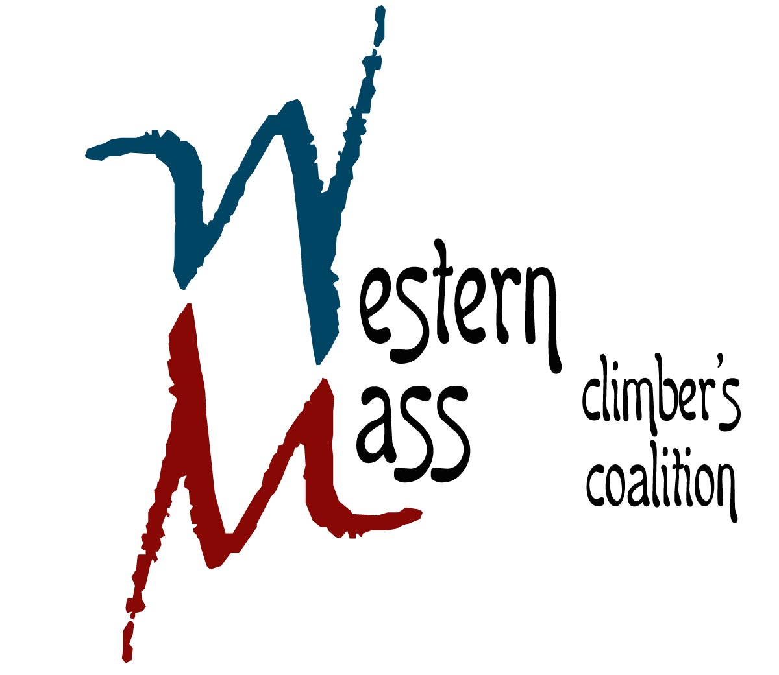
25 Parkview Drive
South Hadley, MA 01075
413.493.1974 www.climbgneiss.org

April 7th, 2014

Mary Ingraham
315 West Comstock St
Seattle, WA 98119

Dear Mary Ingraham

On behalf of the Western Massachusetts Climbers’ Coalition (a registered 501c3, EIN #81-0548355), I would like to take this opportunity to thank you for supporting our organization and helping to protect and preserve climbing and outdoor recreation in Massachusetts.

Your generous donation of a one-week stay of your Decatur Island cottage to our 7th Annual Silent Auction (April 6^{th,} 2014) was an extraordinary gift that allowed us reach our fundraising goals!

Thank you again for your charity and support.

Sincerely,
Peter Clark

President
Western Massachusetts Climbers’ Coalition

